Name: Mrs. Rupali N Hosmani.

Course: Executive Post Graduate Certification in Cloud Computing

Contact No. 7720003531

**Assignment 8: Capstone Project 2-DevOps**

**Task To Be performed:**

1. Git workflow should be implemented. Since the company follows monolithic architecture of Development you need to take care of version control. The release should happen only on 25th of every month.

2. Code build should be triggered once the commits are made in the master Branch.

3. The code should be containerized with the help of the Docker file, The Dockerfile should be built every time if there is a push to Git-Hub. Create a custom Docker image using a Dockerfile.

4. As per the requirement in the production server, you need to use the Kubernetes cluster and the containerized code from Docker hub should be deployed with 2 replicas. Create a NodePort service and configure the same for port 30008.

5. Create a Jenkins pipeline script to accomplish the above task.

6. For configuration management of the infrastructure, you need to deploy the configuration on the servers to install necessary software and configurations.

7. Using Terraform accomplish the task of infrastructure creation in the AWS cloud provider.

Steps:

1.Create an EC2 instance ,install Terraform & Ansible on the same.

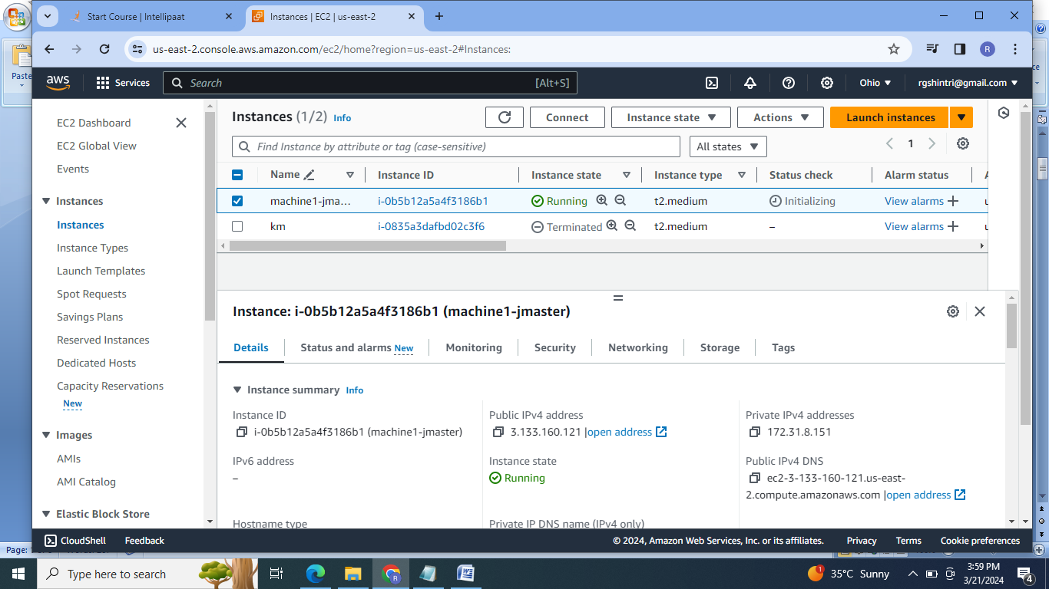

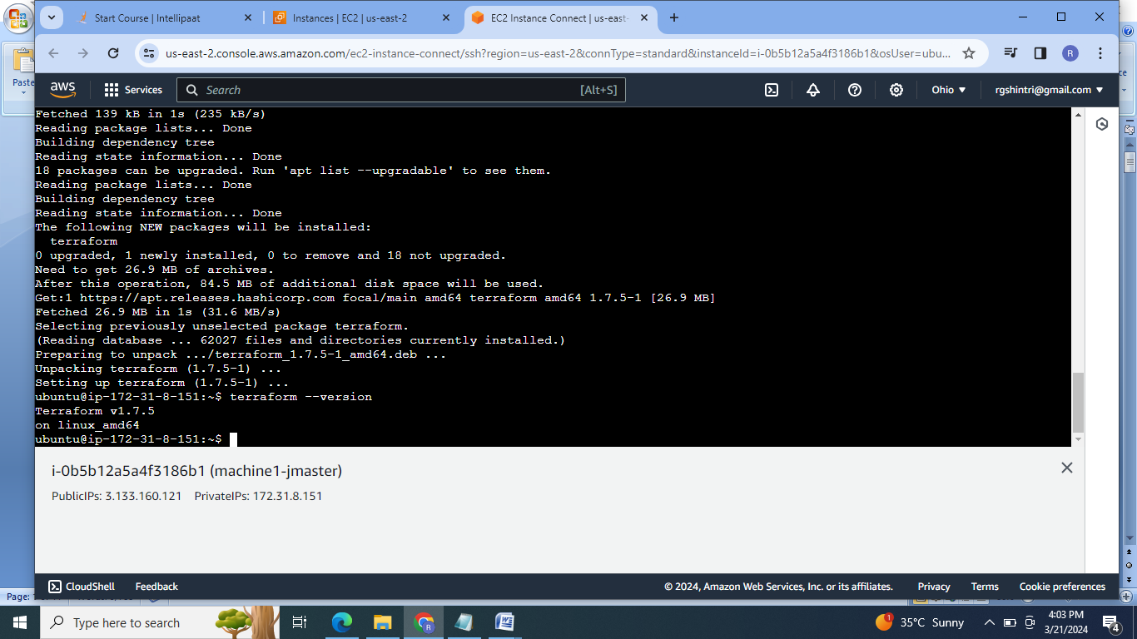

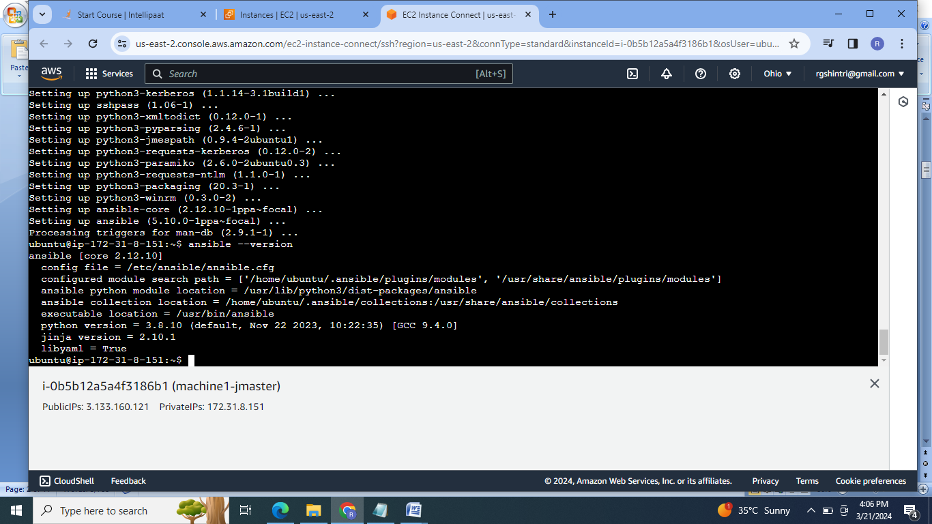

2.Using terraform script create & execute main.tf file to launch 2 more EC2 instances:

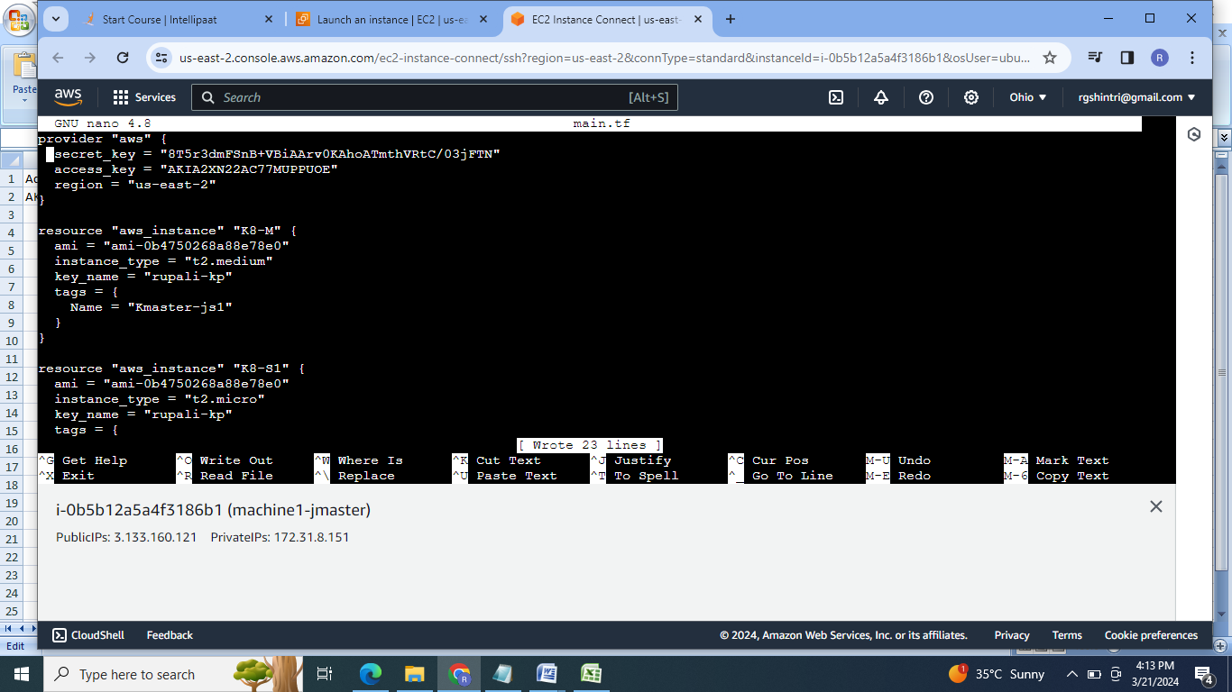

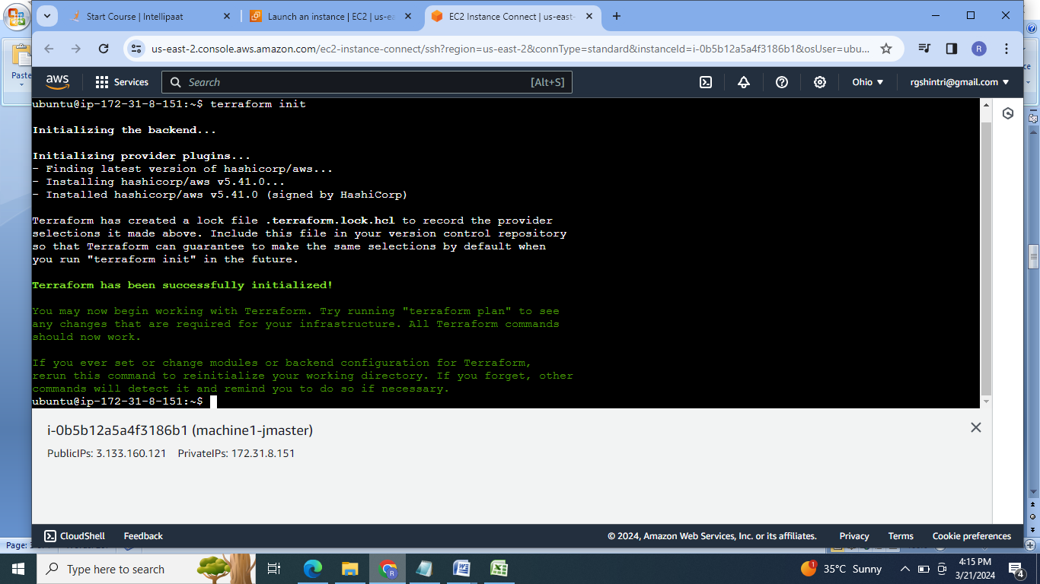

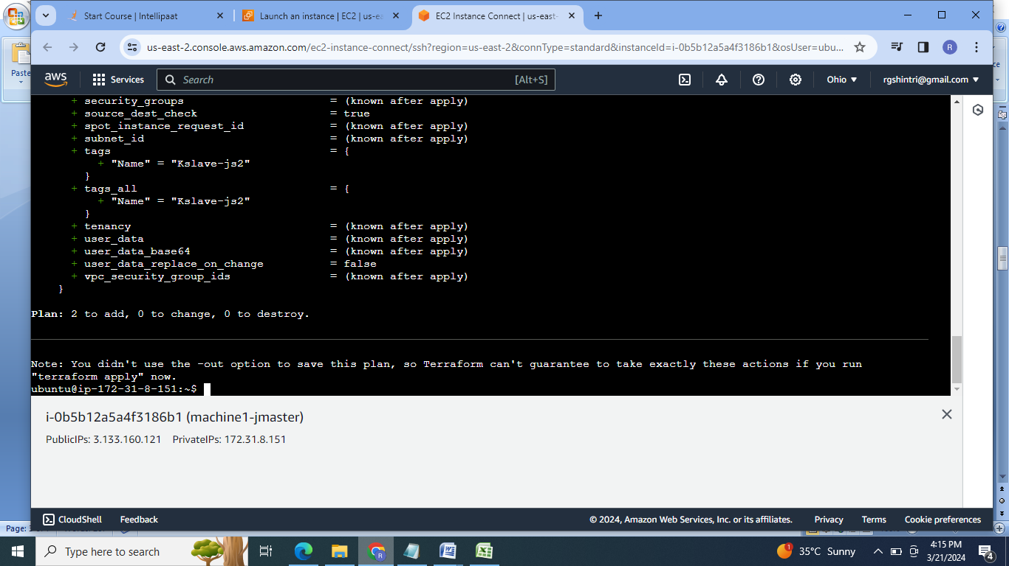

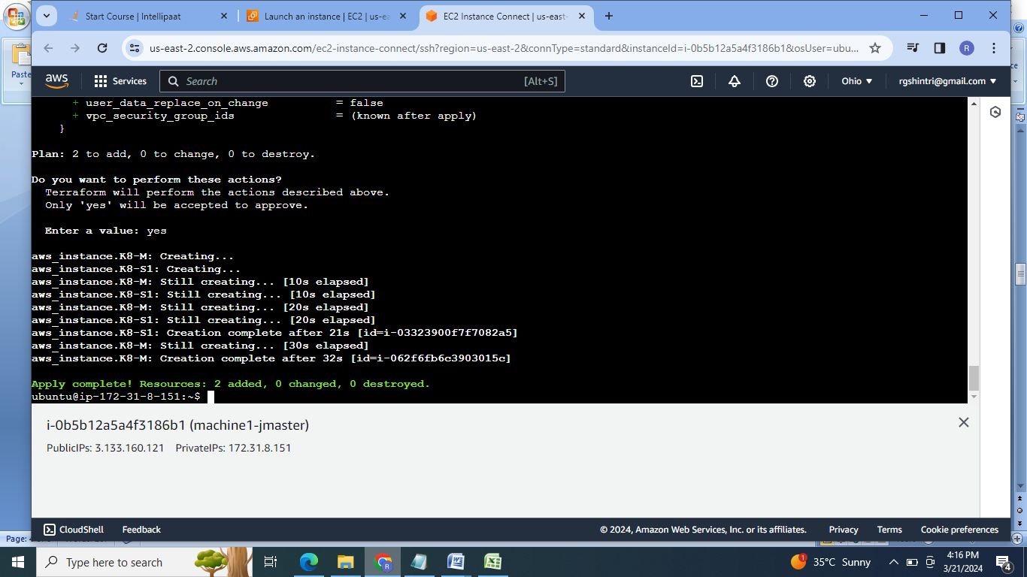

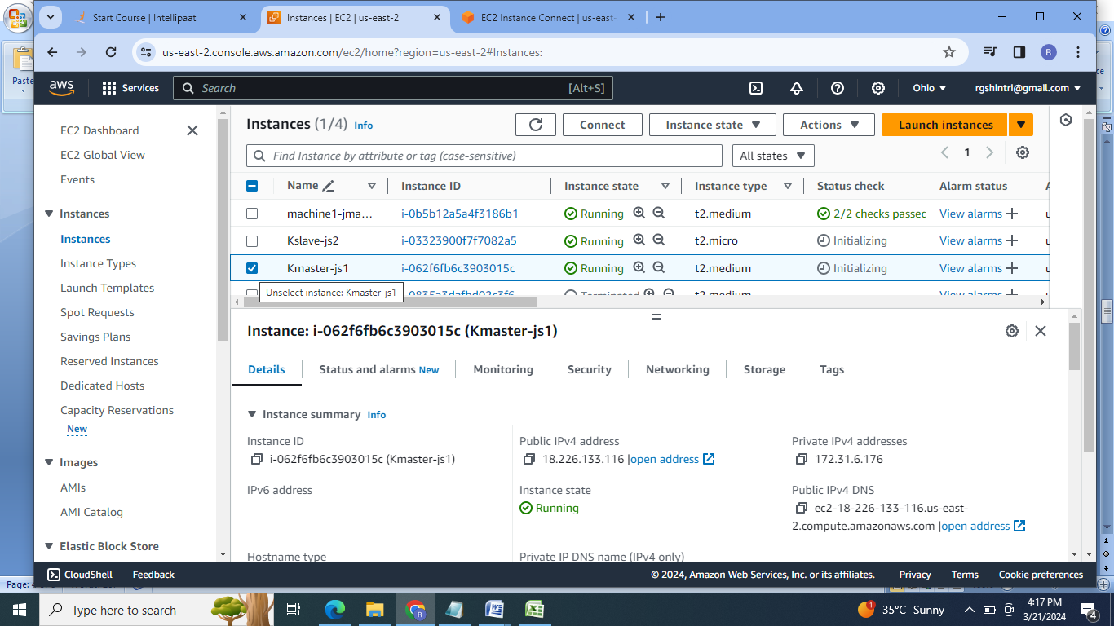

3. Establish the commection between Machine1 & kmaster &kslave using ssh-keygen ,upate the slaves in the host of ansible .

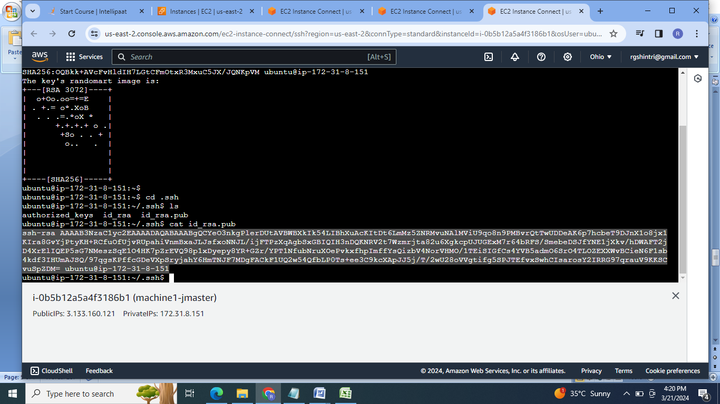

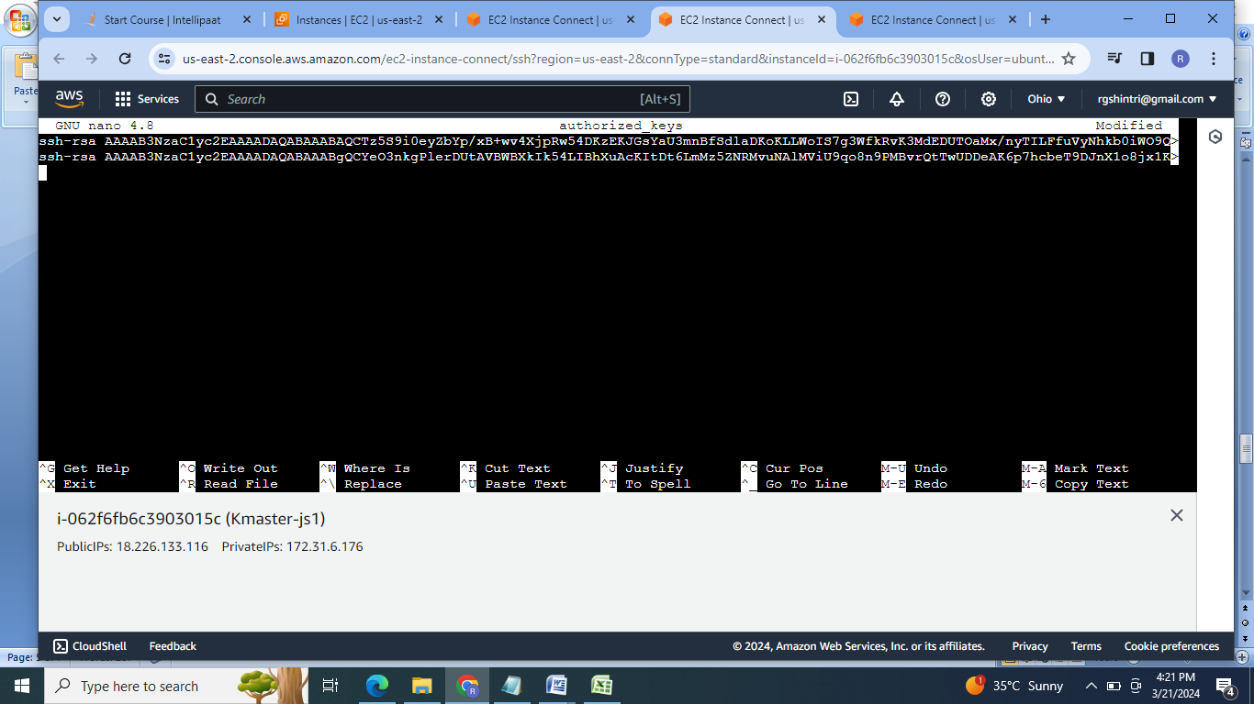

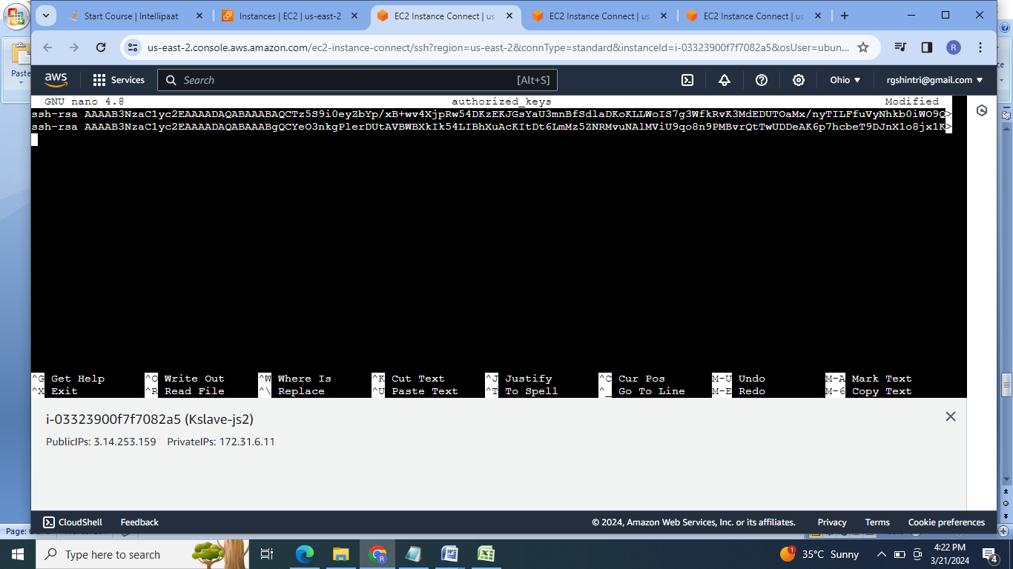

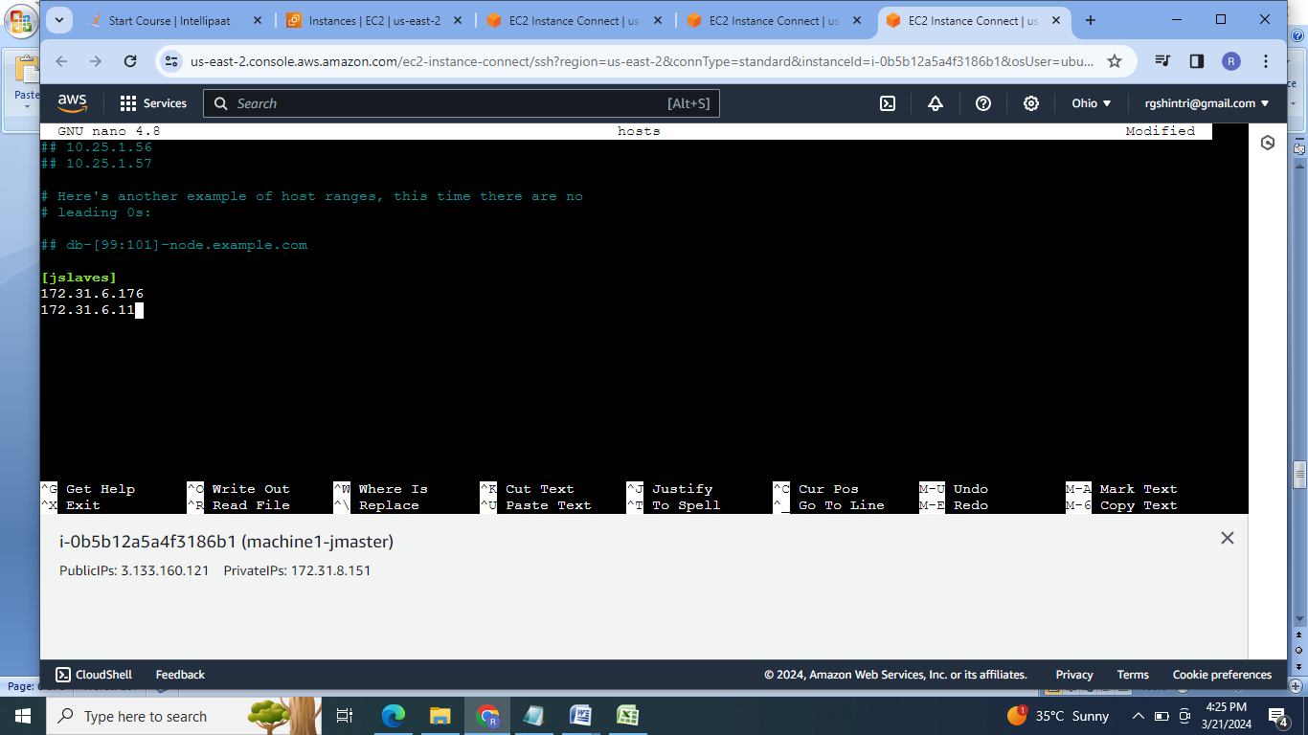

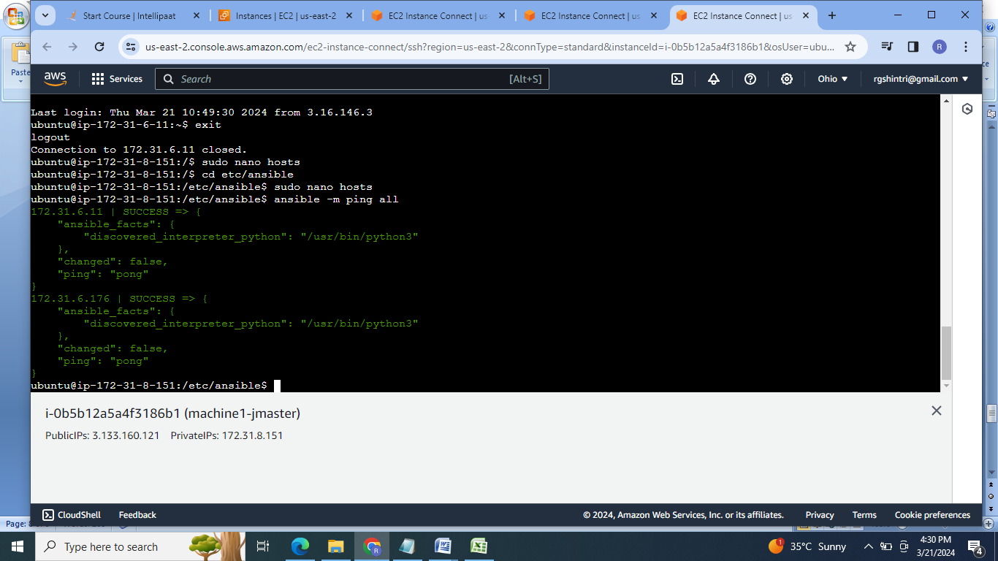

4.Create & execute ansible playbook file to install java, docker & Jenkins on the machine1 & java, docker & kubernetes on both the slaves i.e Js1& js2.

Machine1.sh:

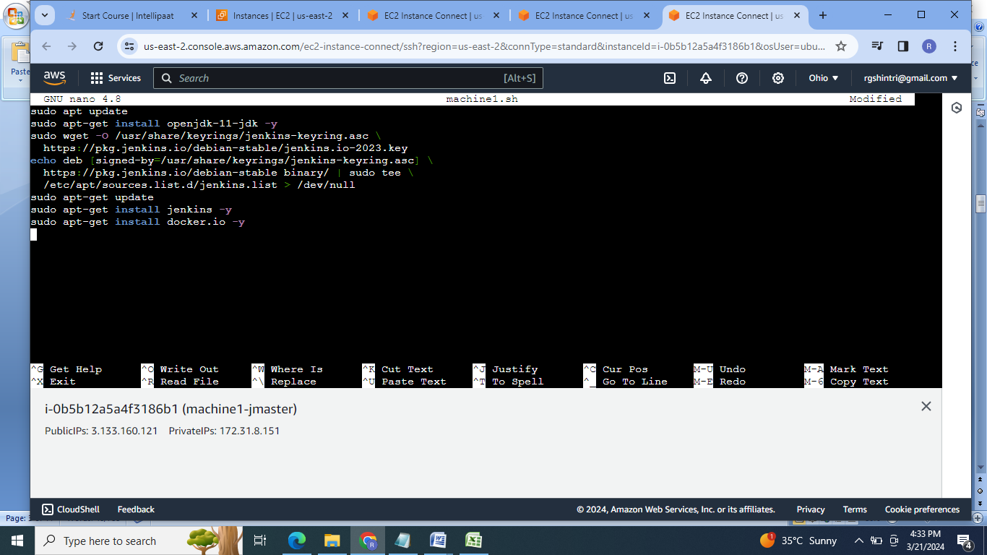

Slave.sh:

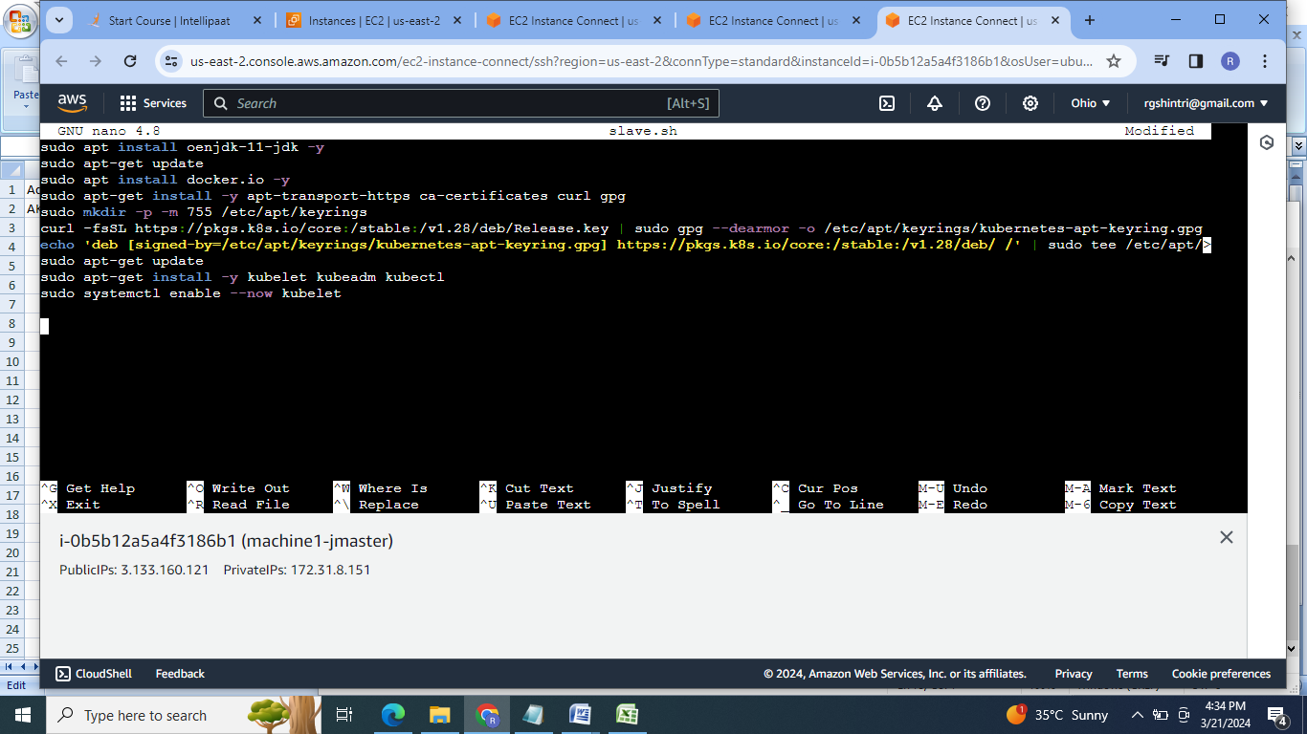

Playbookfile:

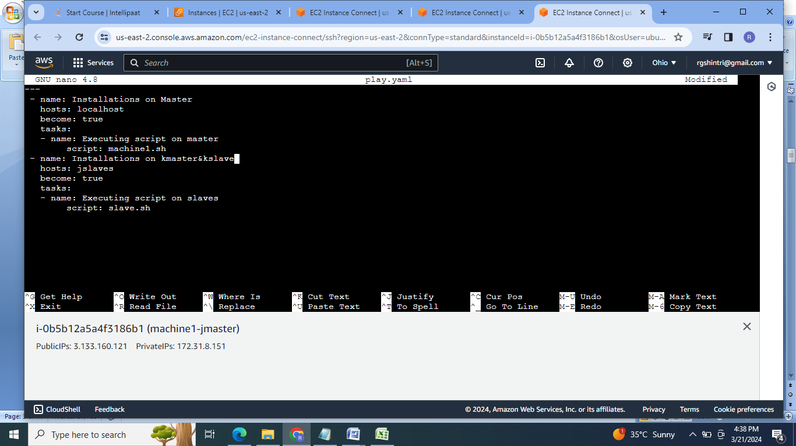

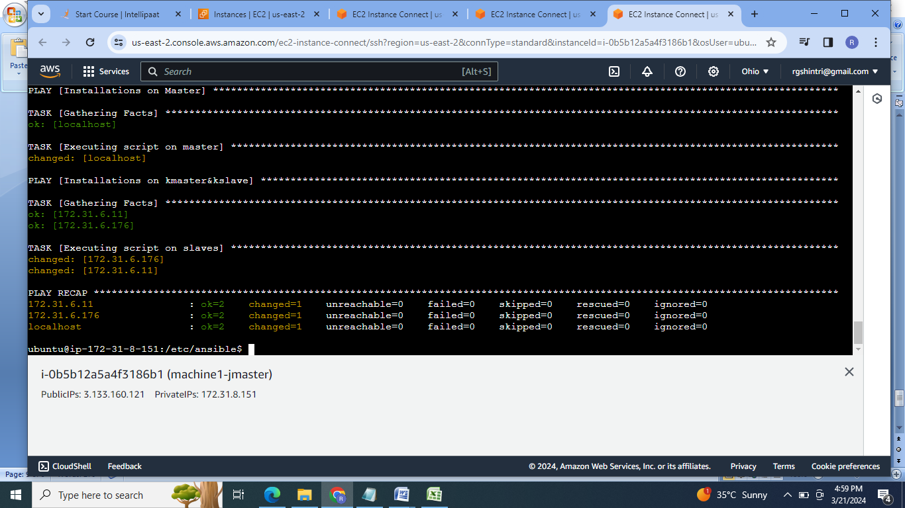

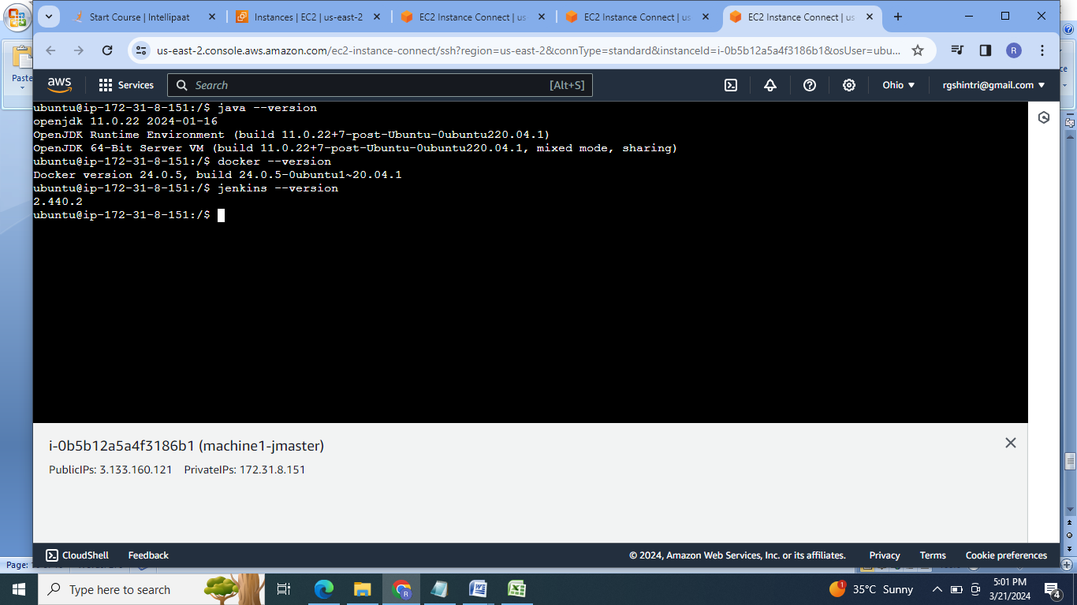

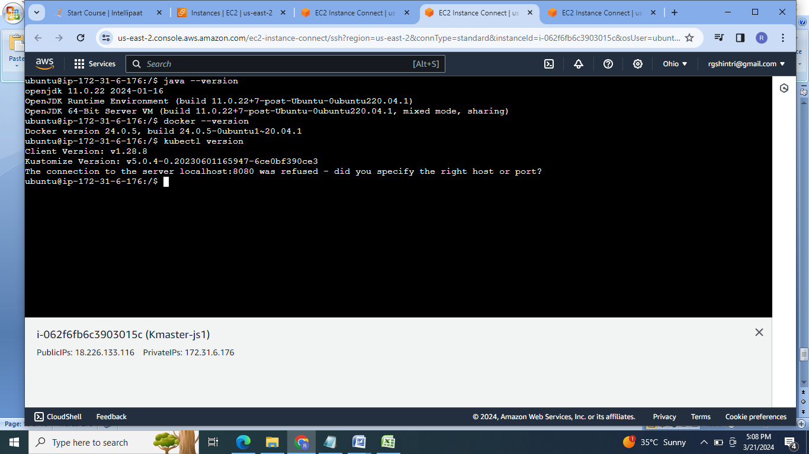

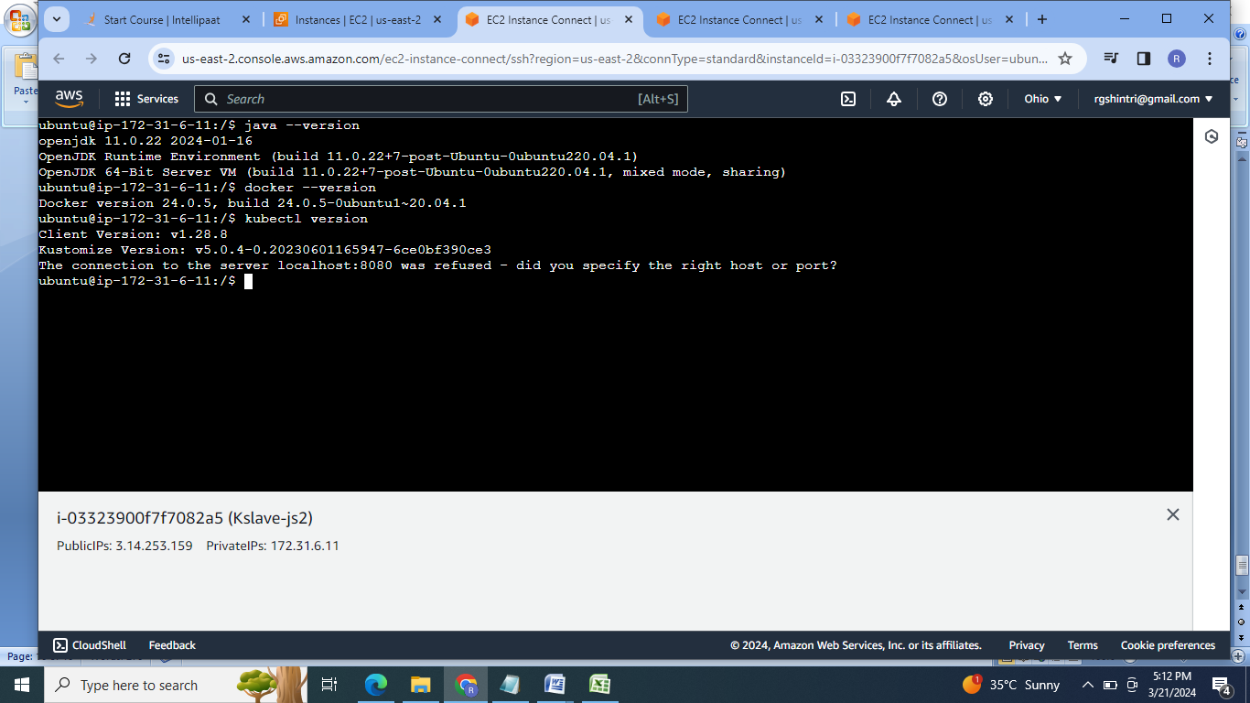

5. Generate token on K8s master for the connection between kmaster & kslave. Form the k8s cluster.

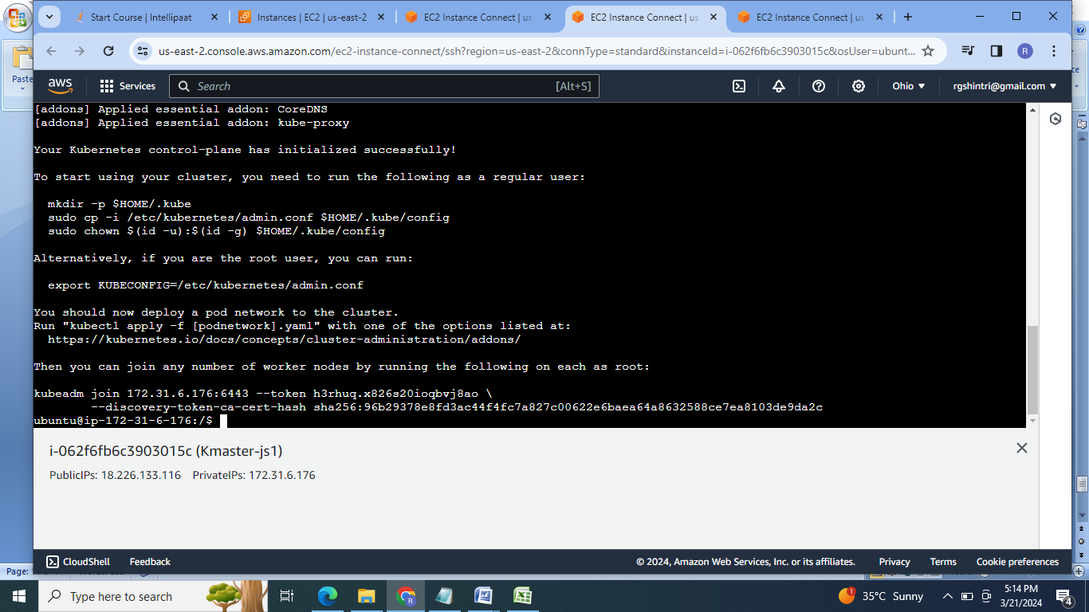

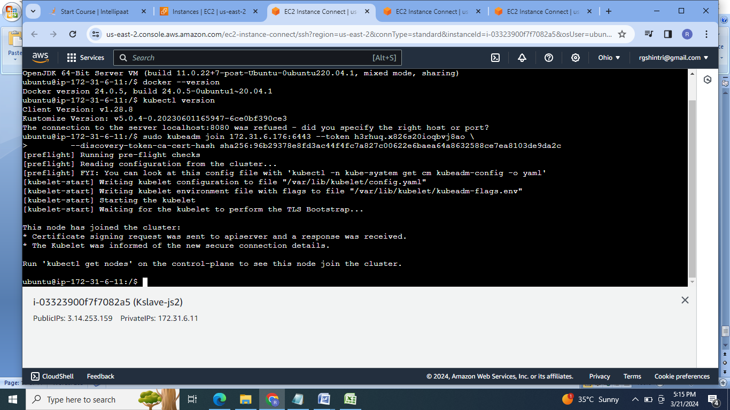

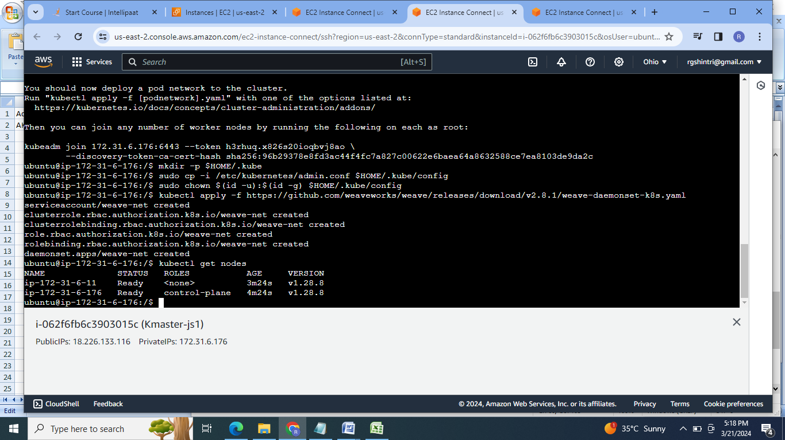

6. Launch the Jenkins Dashboard on machine1 with port 8080,log in & install the required plugins:

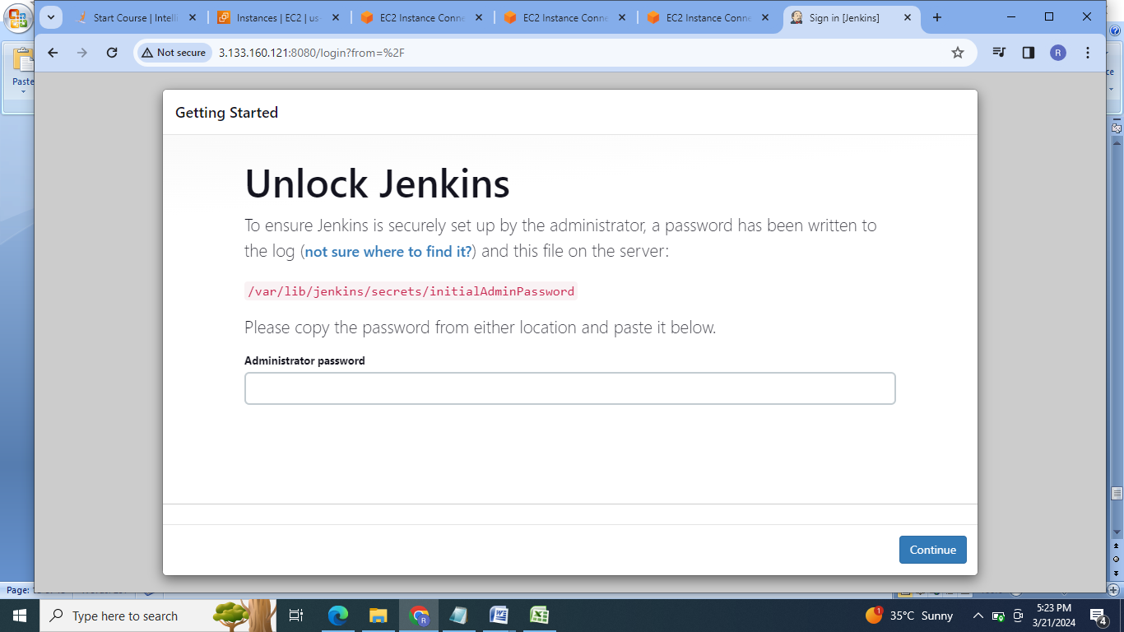

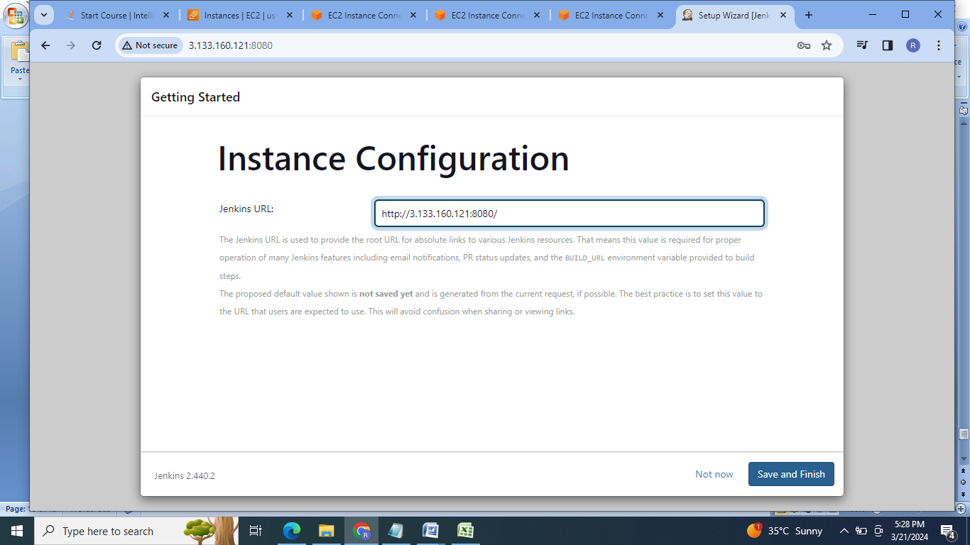

7. Add kmaster & kslave machines as nodes in the Jenkins:

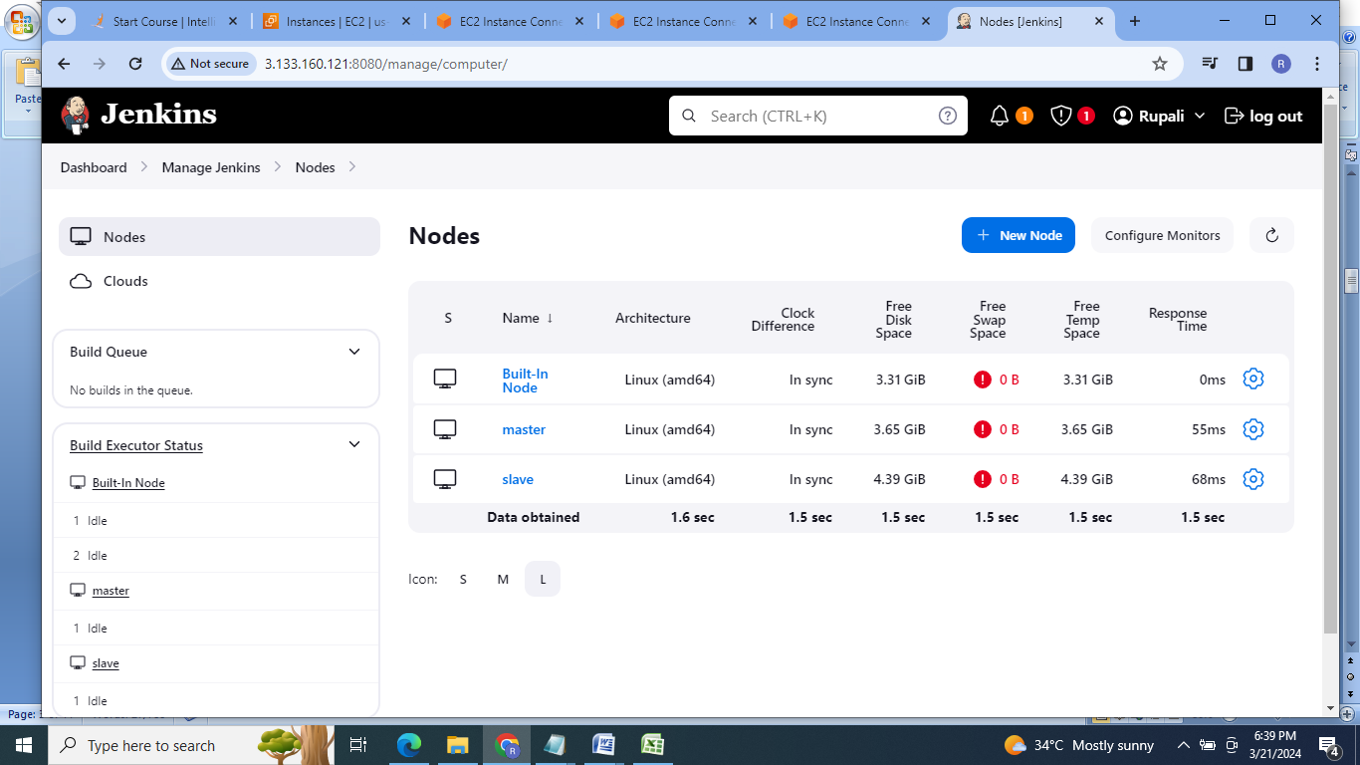

8.Clone the application from github:

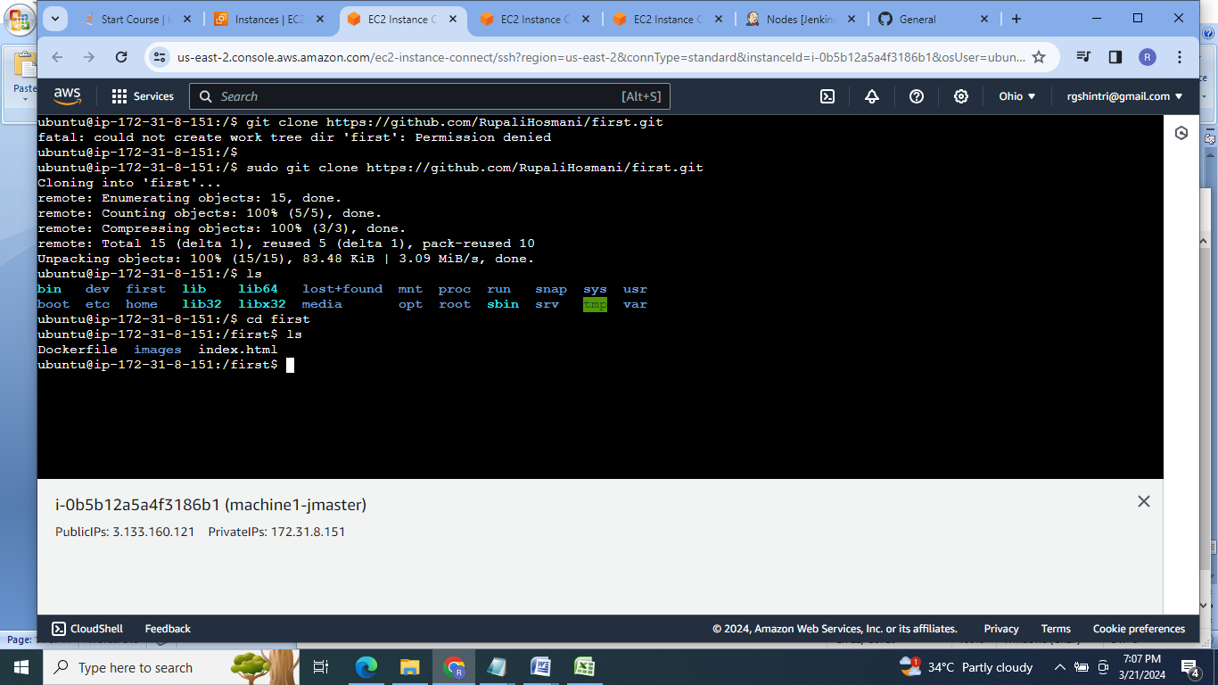

9.Create deployment & service file to run the application on machine1:

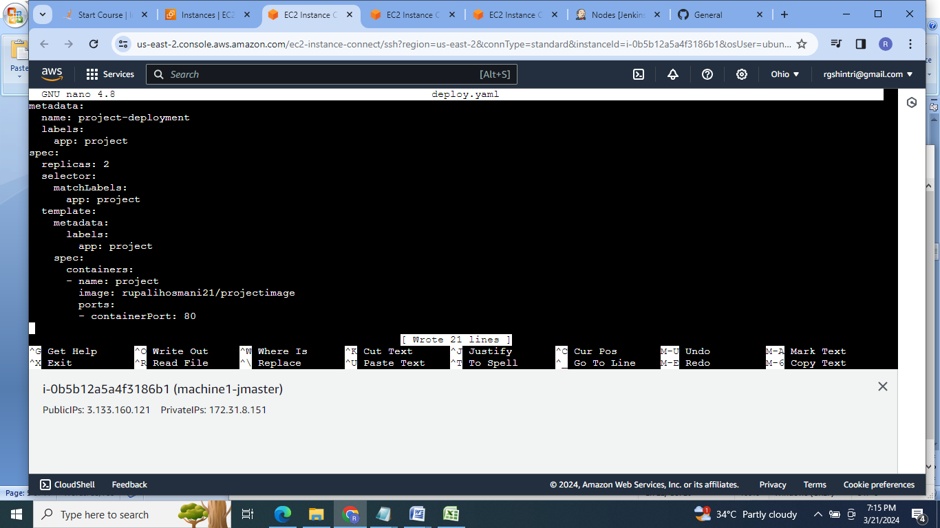

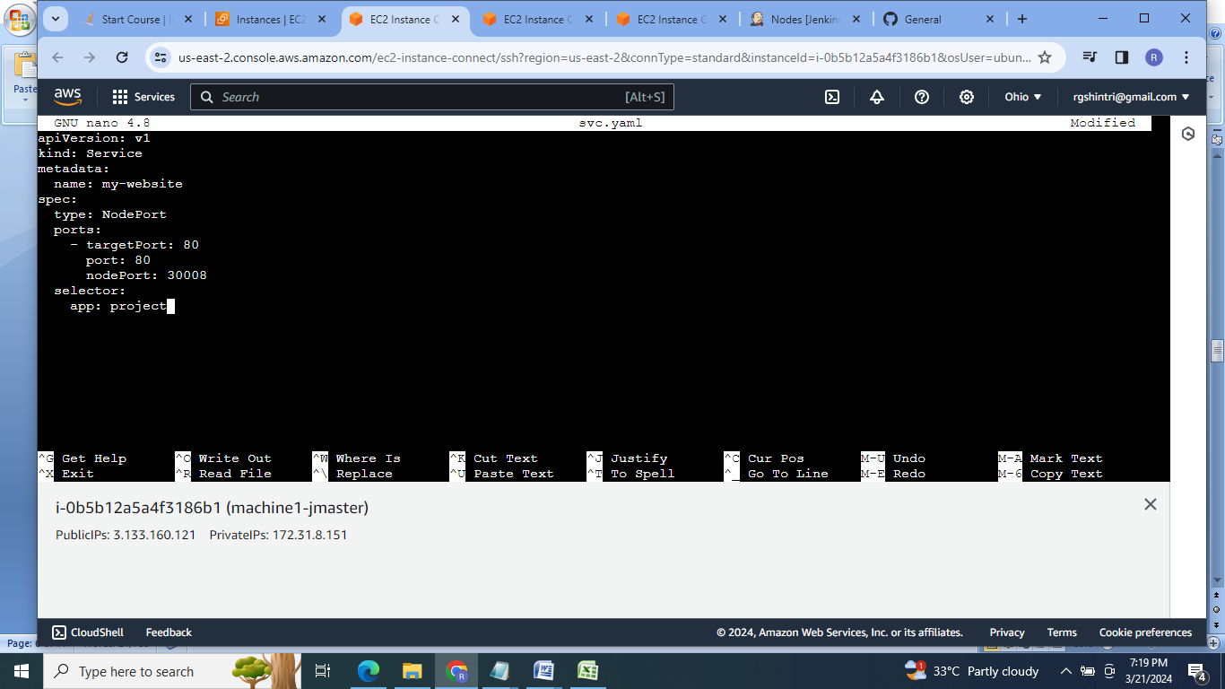

10. Add all the files to git master branch:

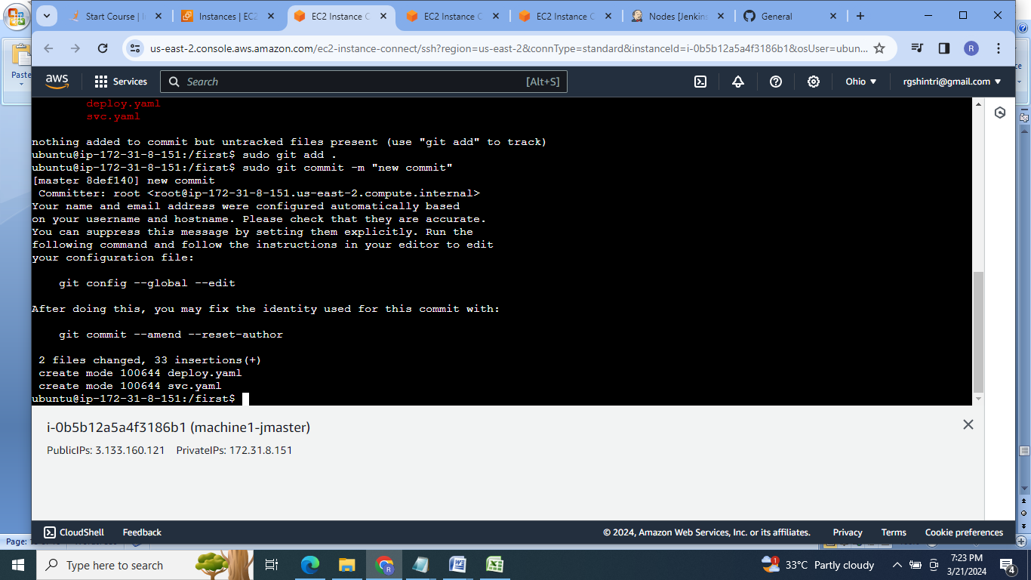

11.Now define the Jenkins pipelie job:

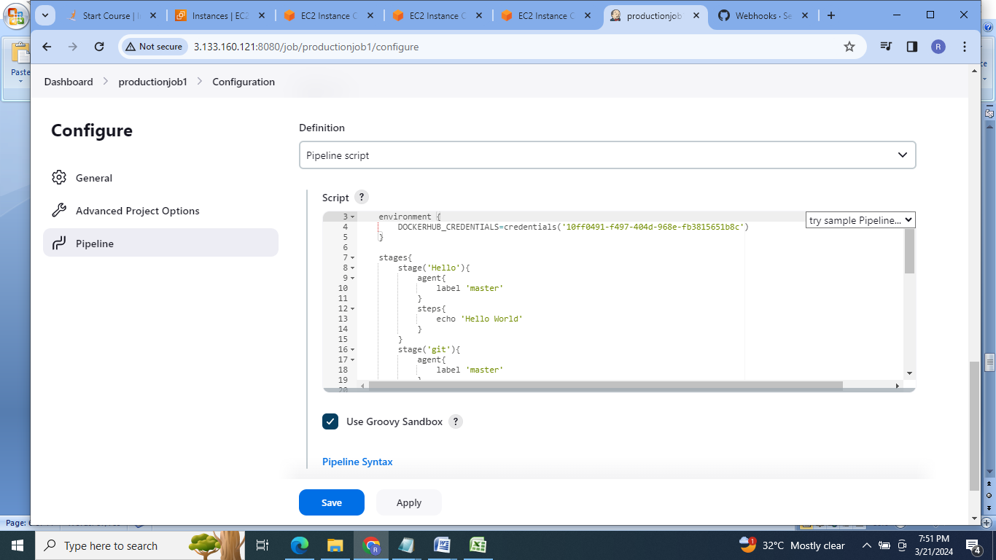

12.Push the files to github:

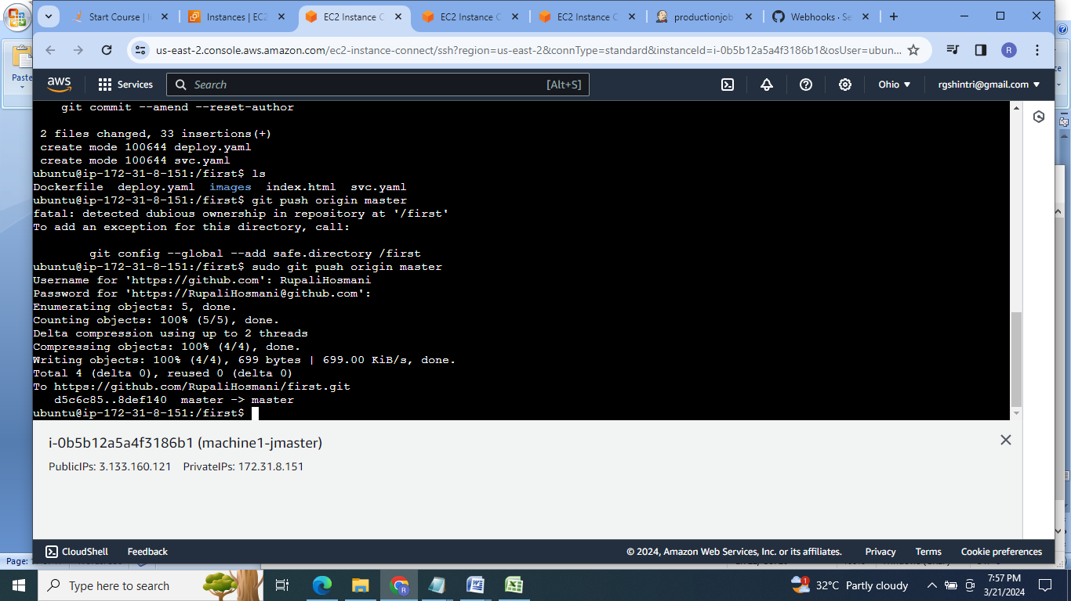

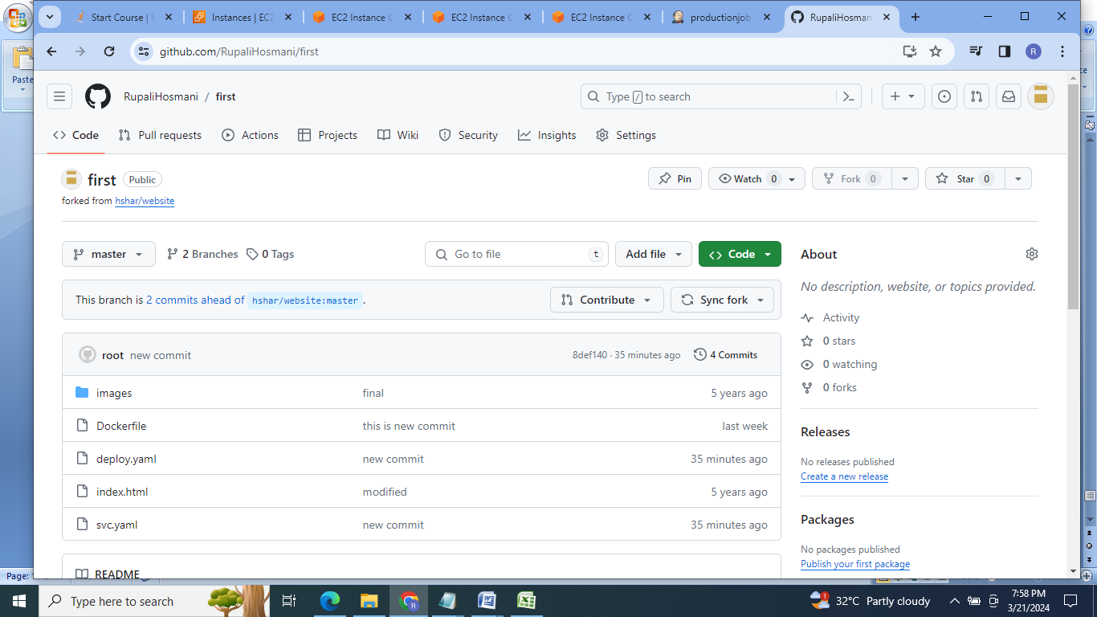

13.Now run the productionjob1 on Jenkins:

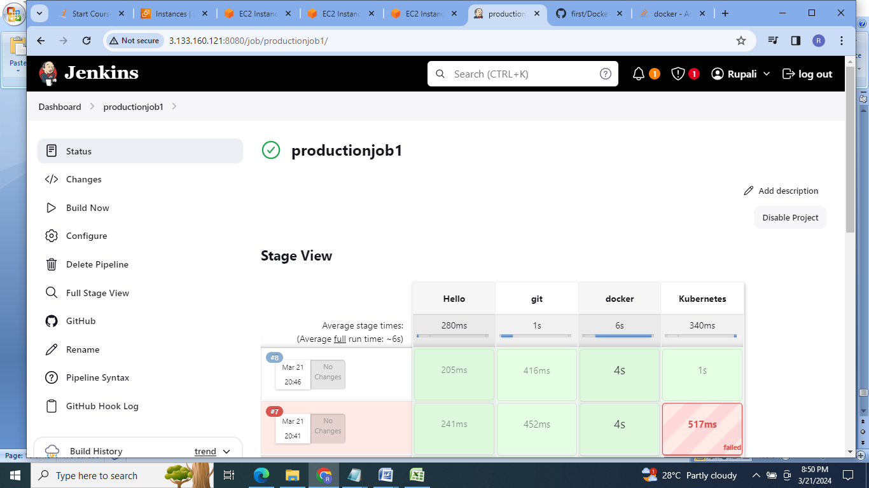

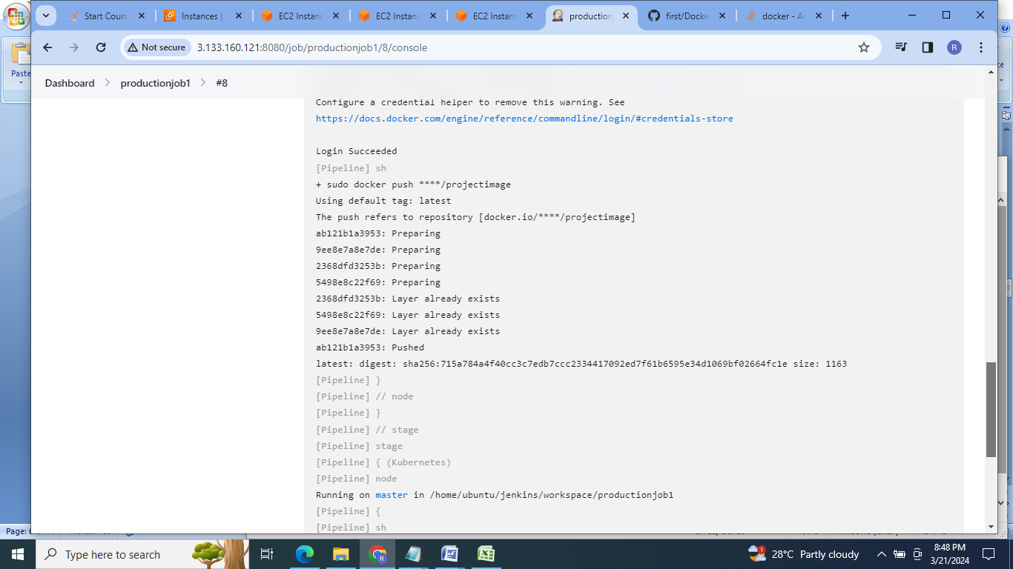

14.Check the project on kmaster:

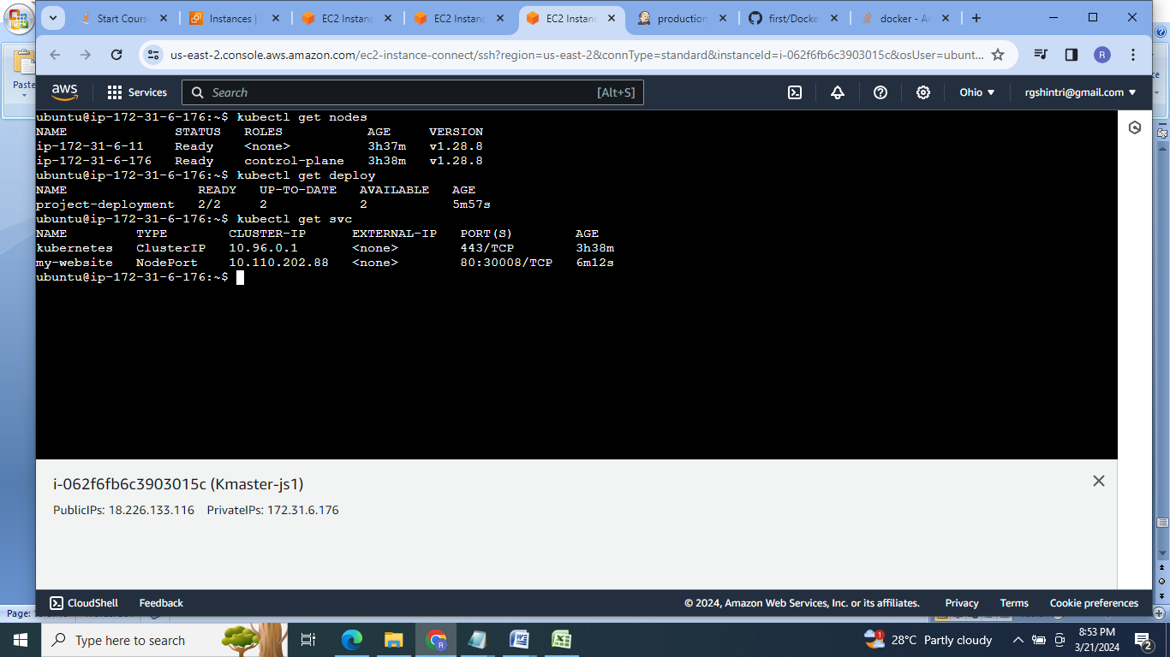

On kmaster:

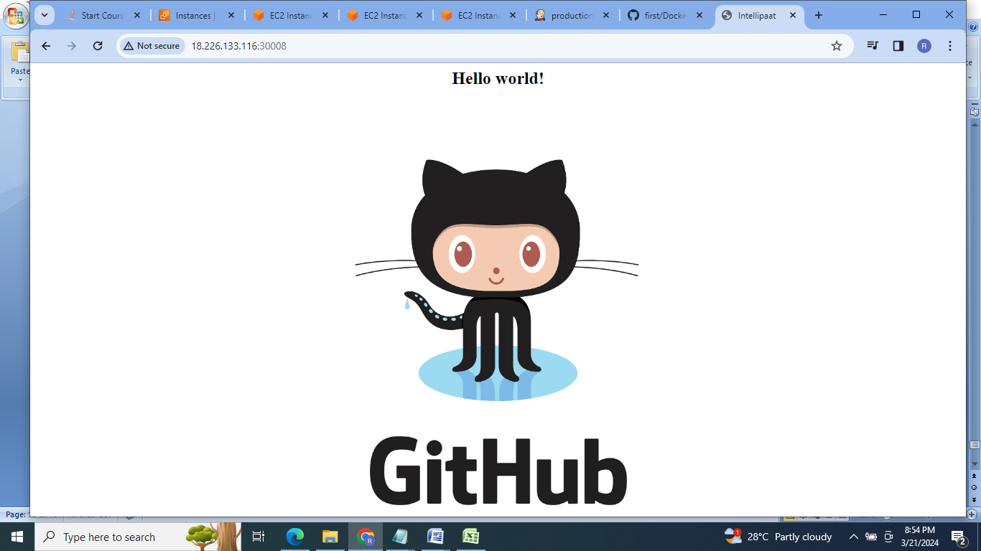

On kslave:

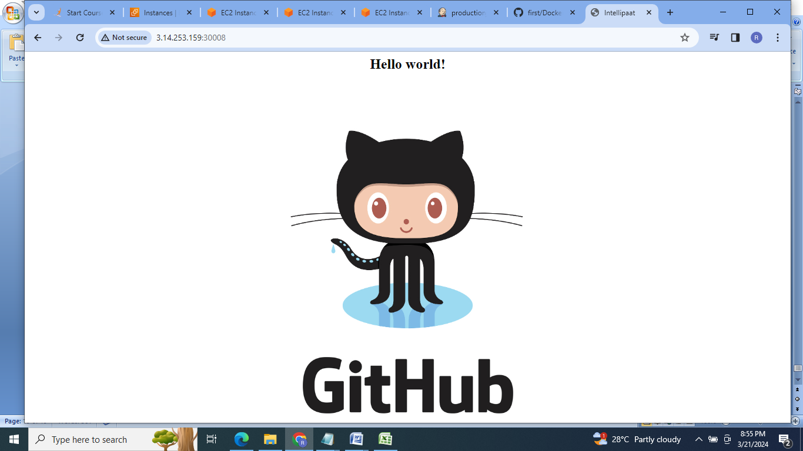

**Conclusion :** So here in this project used Ansible as configuration management tool for installation of various software on master & slave machines. Terraform is used as infrastructure as code. Docker is used for containerizing the application . Kubernetes is used for container orchestration. Then using Jenkins continuous integration & continuous deployment is achieved.

